UNIVERSITY OF SCIENCE AND TECHNOLOGY OF HANOI
DEPARTMENT OF INFORMATION AND COMMUNICATION TECHNOLOGY

BACHELOR THESIS

By
Đỗ Anh Tú
23BI14438

Title:
Feature Development for a Product Promotion Website

External Supervisor: Mr. Lê Văn Tài
Internal Supervisor: Prof. Dr. Trần Hoàng Tùng

Hanoi, July-2026

To whom it may concern,

I, Lê Văn Tài certify that the thesis/ internship report of Mr Đỗ Anh Tú is qualified to be presented in the Internship Jury 2025-2026.

Hanoi, 1 July 2026
Supervisor’s signature

Contents
ACKNOWLEDGEMENTS 5
LIST OF ABBREVIATIONS 6
LIST OF TABLES 6
LIST OF FIGURES 6
ABSTRACT 7
I. INTRODUCTION 8
1.1 Internship Context 8
1.2 Project Overview 8
1.3 Motivation and Problem Background 9
1.4 My Role and Scope of Work 9
1.5 Report Organization 9
II. OBJECTIVES 10
2.1 General Objective 10
2.2 Specific Objectives 10
III. TECHNOLOGIES AND DEVELOPMENT METHODOLOGY 11
3.1 Technologies and Tools 11
3.2 System Architecture 12
3.3 Development Environment 15
3.4 Development Workflow 16
IV. IMPLEMENTATION OF SELECTED FEATURES 16
4.1 Overview of selected features 16
4.2 NG Words Feature 17
4.2.1 Requirement and Scope 17
4.2.2 NG Words Collection and Data Persistence 18
4.2.3 Access Control and CMS Management UI 19
4.2.4 CSV Import and Export Logic 20
4.2.5 NG Words Checking Logic and UI Feedback 23
4.2.6 Result and Discussion 26
4.3 C Point Feature 28
4.3.1 Requirement and Scope 28
4.3.2 Data Flow and Implementation Logic 29
4.3.3 Result and Discusstion 30
4.4 Home Banners Feature 31
4.4.1 Requirement and Scope 31
4.4.2 Data Fetching and Rendering Logic 31
4.5 Other contributions 34
V. CONCLUSION AND PERSPECTIVE 34
5.1 Conclusion 34
5.2 Future Perspective 35
REFERENCES 36
APPENDICES 37
APPENDIX A: Develop and Release Workflow 37
APPENDIX B: Generated Migration File for the NGWords Collection 37
APPENDIX C: Example of Payload Operations for Data Manipulation 38
APPENDIX D: Data Flow Diagram of the C Point Feature 39

ACKNOWLEDGEMENTS

First of all, I would like to express my sincere gratitude to my internal supervisor, Professor Trần Hoàng Tùng, for the guidance, support, and valuable feedback throughout my internship and the preparation of this report. His advice helped me improve the quality of my report, and understand how to present my internship experience in an academic manner.
I would also like to thank my external supervisor, Lê Văn Tài and FPT Software for giving me the opportunity to participate in a real industry project and for providing professional guidance during my internship. Through his supervision, I was able to gain practical experience in software development and better understand the working process in an industry environment.
I am also grateful to all members of the project team for their support, collaboration, and encouragement during my internship. Working with the team gave me the opportunity to learn from real development practices, improve my technical skills, and become more familiar with teamwork in a professional software development environment.
Finally, I would like to thank the Department of Information and Communication Technology at the University of Science and Technology of Hanoi for providing me with the knowledge and foundation necessary to complete this internship successfully.

LIST OF ABBREVIATIONS

CMS | Content Management System
API | Application Programming Interface
SQL | Structured Query Language
UI/UX | User Interface / User Experience
CRUD | Create, Read, Update, Delete
CSV | Comma-Separated Values
HTTP | Hypertext Transfer Protocol
JSON | JavaScript Object Notation
PR | Pull Request
URL | Uniform Resource Locator
CI/CD | Continuous Integration and Continuous Delivery
CORS | Cross-Origin Resource Sharing
NG Words | Not Good Words

LIST OF TABLES
Table 1: List of Technologies and Tools 12

LIST OF FIGURES
Figure 1: Overall System Architecture 13
Figure 2: Component-Level Architecture of the Development Scope 13
Figure 3: Default list view generated by Payload CMS for the NGWords collection 19
Figure 4: NGWords list view with the custom import/export toolbar 20
Figure 5: Example of annotated CSV file returned 21
Figure 6: CSV import workflows for NG words management 22
Figure 7: Example of NG Words review box 26
Figure 8: Example of profile API response before added C Point 28
Figure 9: Simplified homepage banner settings API response 32
Figure 10: Homepage banner rendering examples 33

ABSTRACT

This internship report presents the work carried out during my internship as a full-stack developer intern at FPT Software. The internship was conducted in the context of developing a product promotion website, which is a media platform composed of two main parts: a Content Management System (CMS) for administrators and authors to manage articles, website information, settings, and related content, and a frontweb application for displaying published content to end users.
During the internship, I participated in the development and improvement of several features across the CMS, backend, and frontend layers. My work involved understanding project requirements, analyzing the existing codebase, implementing assigned features, processing data between the backend and frontend, and supporting validation and content management workflows. The main technologies used in the project included Node.js, Payload CMS, PostgreSQL, DBeaver, Firebase, and Next.js/React.
The results of the internship include functional contributions to the platform, improvements to CMS-related workflows, and better integration between backend data and frontend rendering. In addition, the internship allowed me to gain practical experience in full-stack web development, become familiar with an industry software development workflow, and improve my ability to work with a real project team.

INTRODUCTION

Internship Context
As part of the Bachelor program in Information and Communication Technology at the University of Science and Technology of Hanoi, students are required to complete an internship in order to apply academic knowledge to a real working environment. This internship provides an opportunity to understand how software systems are developed in industry, how development teams collaborate, and how technical solutions are implemented based on practical requirements.
My internship was carried out at FPT Software from April 1, 2026 to July 1, 2026. During this period, I worked as a Full-stack Developer Intern in a software development team. The project was developed in an outsourcing environment, where the client’s business requirements were transformed into technical tasks and implemented by the development team. Due to confidentiality reasons, the client’s name and some business details are not disclosed in this report.
The internship allowed me to participate in a real project with an existing codebase, development workflow, and team structure. My main responsibility was to work on assigned functional requirements, including feature development, bug fixing, and adjustments based on project requirements. Through this experience, I had the opportunity to improve my technical skills in CMS development, backend logic, frontend rendering, and database-related tasks.

Project Overview
The project involved the development of a Product Promotion Website for a supermarket retail system. The system can be considered a media platform whose main purpose is to manage, publish, and display promotional content related to products, campaigns, and marketing programs. The platform helps content managers organize information efficiently and provides end users with a web interface to access published content.
The system consists of two main parts: the Content Management System (CMS) and the Frontweb application. The CMS is used by internal users such as administrators, authors, and moderators to manage articles, website information, media resources, settings, and other content-related data. Depending on the configuration, different CMS users may have different permissions, such as creating articles, editing content, reviewing posts, or managing system settings. The administrator has the highest level of permission and can configure the roles and access rights of other users.
The Frontweb application is the public-facing part of the system. It displays published content to end users, including article lists, article details, featured content, promotional campaigns, and product-related information. It also supports content classification and discovery through categories and tags. In addition, the platform includes user interaction features such as social network sharing, content recommendation, advertising banners, ad slots, and media management for images and videos.

Motivation and Problem Background
In a product promotion platform, content must be created, reviewed, managed, and displayed correctly. Articles and promotional pages may contain different types of information, such as text, images, links, banners, and interactive elements. Therefore, the system needs to support flexible content management while still ensuring that the published content follows the expected structure and quality requirements.
From a development perspective, this creates several technical challenges. First, the CMS must provide suitable interfaces and data structures for content creators to input and manage information. Second, the backend must process, validate, and provide data correctly to other parts of the system. Third, the frontend must render the received data properly so that end users can view and interact with the content. In addition, the system needs to support maintainability because new requirements and changes may appear during the development process.
During the internship, my work focused mainly on functional development tasks related to CMS features, backend logic, and frontend display. These tasks required me to understand the existing system architecture, analyze the relationship between different components, implement new behavior, and test the results to ensure that the features worked as expected. The work was not limited to a single layer of the application, but involved multiple parts of the system, which made it a valuable full-stack development experience.

My Role and Scope of Work
As a Full-stack Developer Intern, I participated in the development team and worked on tasks assigned by the project leader and senior developers. My work mainly focused on implementing functional requirements, fixing issues, and adjusting existing features according to project needs. The tasks involved working with the CMS, backend, database, and frontweb application.
In the CMS, I worked on features related to content management and configuration. In the backend, I contributed to logic processing and validation to support content workflows. In the frontend, I worked on rendering data received from the CMS or backend so that the content could be displayed correctly to users. I also used development tools to inspect data, understand the existing implementation, and test the behavior of implemented features.
The scope of this report does not cover the entire system or all features developed by the project team. Instead, it focuses on my own contribution as a developer intern. To keep the report concise and technically meaningful, only selected features and use cases are presented in detail. These selected use cases are used to illustrate the development process, implementation logic, and results of my work during the internship.

Report Organization
The remainder of this report is organized as follows. Chapter II presents the objectives of the internship, including the general objective and specific objectives related to technical learning and project contribution. Chapter III introduces the technologies, tools, system architecture, and development methodology used during the internship. Chapter IV presents selected implemented features and discusses their requirements, technical logic, results, and limitations. Finally, Chapter V concludes the report by summarizing the main achievements of the internship and suggesting possible future improvements.

OBJECTIVES

General Objective
The general objective of this internship was to apply a systematic software engineering approach to the development of functional features for a real product promotion platform. The internship aimed to analyze the requirements of a content-based web system, understand its architecture, implement assigned features across different application layers, and evaluate the correctness of the implemented functions through testing and review.
In the context of this project, the objective was not only to participate in software development tasks, but also to understand how a large-scale web application supports content management, data processing, and content presentation.

Specific Objectives
The specific objectives of the internship were as follows:
- To analyze the architecture and workflow of a real product promotion platform, including the interaction between the CMS, backend, database, and frontweb application.
- To study how functional requirements are translated into technical implementation tasks in an industry software development environment.
- To design and implement assigned features that support content management, content validation, data processing, and frontend rendering.
- To investigate the existing codebase in order to understand its structure, coding conventions, data flow, and dependency between system components.
- To apply software engineering practices to modify and extend existing functionalities while maintaining consistency with the current system design.
- To verify implemented features through local testing, debugging, and review in order to ensure that the results satisfy the expected behavior.
- To identify technical difficulties during implementation and propose suitable solutions or adjustments when necessary.
- To improve practical development skills, including problem analysis, code comprehension, debugging, communication, and collaboration within a professional development team.
Through these objectives, the internship aimed to combine academic knowledge with practical software engineering experience, allowing me to develop both technical competence and a deeper understanding of real-world web application development.

TECHNOLOGIES AND DEVELOPMENT METHODOLOGY

Technologies and Tools
The main programming languages used in the project were JavaScript, TypeScript, and JSX. JavaScript and TypeScript were used for implementing application logic, configuration, data processing, and feature behavior across different parts of the system. JSX was mainly used in the frontend part of the system to define React user interface components.
Payload CMS was used as the main framework for building the CMS. It provided the administrative interface for managing articles, media, website settings, banners, and other content-related data [1]. In the project, data structures were mainly defined through Payload collections and globals. These configurations allowed the system to organize different types of content and settings in a structured way. Payload also provided APIs and server-side functions for interacting with stored content, which reduced the need to directly handle low-level database operations in most feature implementation tasks [1].
PostgreSQL was used as the main relational database of the system [2]. However, in the scope of my internship tasks, database operations were mostly performed indirectly through Payload CMS. When new fields or data structures were required, they were usually added by modifying Payload collections or globals rather than by manually writing SQL queries. The Payload PostgreSQL adapter was responsible for connecting the CMS configuration with the PostgreSQL database and supporting schema migration generation based on changes in the Payload configuration [1].
The frontweb application was developed using Next.js and React [3], [4]. It was responsible for displaying published content to end users, such as article lists, article details, featured articles, promotional content, banners, and other user-facing components. Styling was implemented using Tailwind CSS, SCSS, and CSS modules, depending on the component and the existing structure of the project [5].
Firebase was used for end-user account management on the frontweb side [6]. The account system was shared with an existing client-side application, allowing the web application to reuse the available user account infrastructure. In this project, Firebase was part of the overall system architecture, while my main work focused more on CMS, backend logic, and frontend feature implementation.
DBeaver was used as a database management and inspection tool. Although I did not directly write raw SQL queries for feature implementation, DBeaver was useful for checking data, understanding stored records, and verifying the result of some operations when necessary.
Figma was used as a design reference tool. It helped developers check the expected layout, spacing, and visual behavior of user interface components before or during implementation. This was especially useful for frontend tasks that required matching the design specification.
Visual Studio Code was used as the main code editor during development. Git and GitHub were used for version control and source code management [7], [8]. These tools allowed developers to manage code changes, track implementation history, and collaborate within the project repository.
Category | Technologies / Tools | Purpose
Programming languages | JavaScript, TypeScript, JSX | Application logic, configuration, data processing, and UI component development
CMS framework | Payload CMS | Content management, admin interface, collections, globals, and CMS-related APIs
Database | PostgreSQL | Main relational database of the system
Database tool | DBeaver | Database inspection and data verification
Frontend framework | Next.js, React | Frontweb application and user-facing pages
Styling | Tailwind CSS, SCSS, CSS modules | User interface styling and layout implementation
Account management | Firebase | End-user account management integration
Design reference | Figma | UI design and layout reference
Code editor | Visual Studio Code | Source code editing and development
Version control | Git, GitHub | Source code management and collaboration
Table 1: List of Technologies and Tools

System Architecture
This section presents the overall architecture of the system developed in the project. The platform was designed as a full-stack web system composed of two main applications: the CMS Admin application and the Frontweb application. These two applications were maintained in separate repositories and served different types of users. The CMS Admin application was used by internal users such as administrators and editors to manage content, settings, media, and other website data. The Frontweb application was the public-facing website used to display published content to end users.

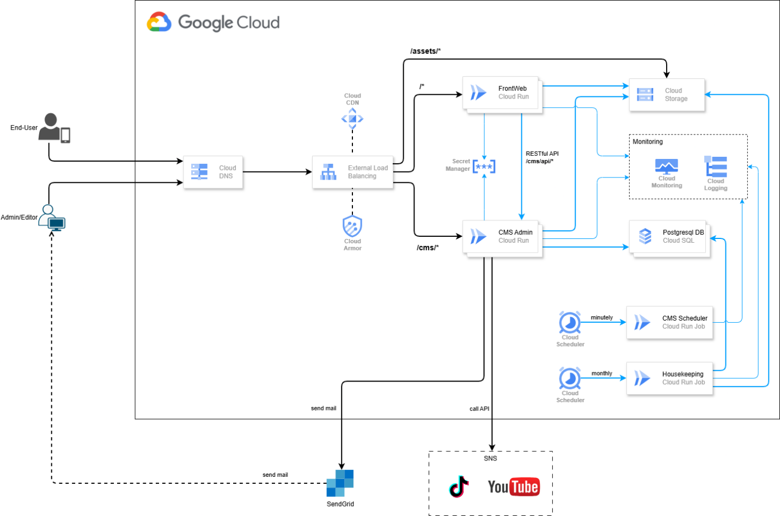
Figure 1: Overall System Architecture
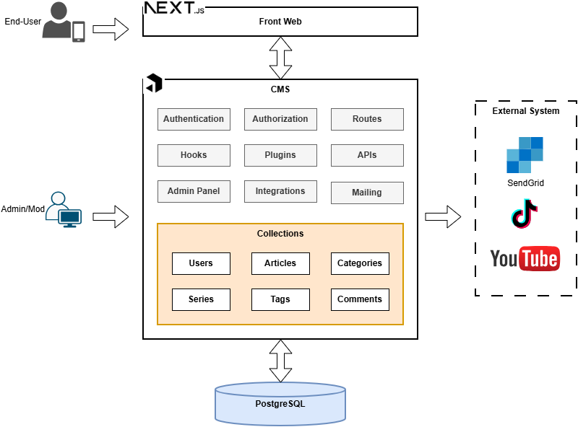
Figure 2: Component-Level Architecture of the Development Scope
In addition to the overall system architecture, the project can also be viewed from a component-level development scope. Figure 2 shows the main application components that were directly related to development tasks during my internship.
The system was deployed on Google Cloud. Both the CMS Admin application and the Frontweb application were hosted on Cloud Run [9]. User requests were routed through Cloud DNS and an external load balancer. Based on the route, requests could be directed either to the Frontweb application or to the CMS Admin application. For example, general public routes were handled by the Frontweb application, while CMS-related routes were handled by the CMS Admin application.
The CMS Admin application was built using Payload CMS. It provided both the administrative interface and the CMS API. In the system architecture, the CMS Admin and CMS API belonged to the same Payload-based application, but they were accessed through different routes. The CMS interface was used by administrators and editors to manage content, while the CMS API provided endpoints for both CMS-side operations and Frontweb data consumption. For CMS-side operations, the API was used to manage or retrieve data for the administrative interface. For the Frontweb application, separate API endpoints were provided to expose published or public-facing data.
PostgreSQL, hosted on Cloud SQL, was used as the main relational database of the system [10]. It stored CMS-related data such as articles, website settings, banner information, media metadata, and CMS user accounts. In the local development environment, PostgreSQL was set up and used locally, and the application connection was adjusted through environment variables. This allowed developers to work and test features locally before the changes were deployed to shared environments. The accounts of CMS users, such as administrators and editors, were stored in PostgreSQL. In contrast, end-user accounts on the Frontweb side were managed by an existing client-side account platform and were not included as a main component in this architecture description.
The Frontweb application communicated with the CMS API to retrieve published content and configuration data. In practice, the Frontweb did not always call the CMS API directly from client-side components. To avoid CORS-related issues and to centralize data fetching logic, the Frontweb repository defined internal API routes. These internal routes then called helper functions in the Frontweb codebase, which finally fetched data from the real CMS API. This structure helped separate frontend page logic from CMS API communication and made the data-fetching process easier to maintain.
Media files were stored in Cloud Storage [11]. When an administrator or editor uploaded media files such as images or videos through the CMS, the files were stored in cloud storage and could later be used by the Frontweb application. This allowed both CMS and Frontweb to share the same media resources. In the local development environment, however, Google Cloud Storage was disabled because of network and proxy limitations. Therefore, uploaded media files were stored locally during development.
The system also included several supporting cloud services: Secret Manager, Cloud Monitoring, Cloud Logging, Cloud Scheduler, Cloud Run and SendGrid These services supported the overall operation of the system, although they were not the main focus of my internship tasks.

Development Environment
The local development environment was used to implement and verify features before the code was submitted for review. Since the CMS and Frontweb were maintained in separate repositories, each application had its own environment configuration and could be run independently depending on the assigned task.
For CMS development, the application was run locally on port 3000. The CMS admin panel was accessed through http://localhost:3000/admin/cms. A local PostgreSQL database was used during development, and the database connection was configured through environment variables. This allowed CMS features to be developed and tested without connecting to the deployed database.
The CMS also required migration and seed steps during local setup. Migrations were used to prepare or update the local database schema, while seed data was used to create initial roles and an administrative account for testing. When changes were made to Payload collections, globals, or permissions, migration files could be generated and applied to the local database before testing the updated behavior.
For media handling, the local environment was different from the deployed environment. In deployed environments, media files were stored in Google Cloud Storage. However, during local development, cloud storage was disabled because of company network and proxy limitations. As a result, uploaded media files were stored locally, which allowed media-related features to be tested without depending on external cloud storage.
For Frontweb development, the application was run locally on port 4000 and accessed through http://localhost:4000. The Frontweb environment file contained values such as the site URL and the CMS URL. In local development, the CMS URL pointed to the locally running CMS application so that the Frontweb could retrieve test data from the local CMS.
When a task only affected the CMS, I usually ran only the CMS repository. When a task involved displaying CMS data on the Frontweb, both repositories were run at the same time. This made it possible to test the complete local flow from CMS data management to Frontweb rendering before pushing the implementation for review.
The local development setup reproduced the main behavior needed for feature implementation while remaining independent from deployed services. Local PostgreSQL, local media storage, and environment-based configuration allowed development and testing to be performed safely before the changes were moved to shared environments.

Development Workflow
The development workflow followed a sprint-based process, where tasks were estimated, selected for a sprint, and assigned to developers by the team leader. As a developer intern, my main responsibility was to implement assigned functional requirements, test them locally, and submit the completed work for code review.
For each task, a new working branch was created from the develop branch. The implementation was first developed and tested in the local environment. Depending on the task, this could involve changes in the CMS repository, the Frontweb repository, or both. Before submitting the task, the feature was checked locally to ensure that the main behavior worked as expected and did not break related flows.
After local verification, the working branch was pushed to GitHub and a pull request was created into the develop branch. The pull request was reviewed by senior developers. If there were review comments, the implementation was updated and pushed again until it was approved. After approval, the pull request was merged into develop.
Once changes were merged into develop, the CI/CD pipeline automatically deployed the updated code to the development environment. This environment was used to test integrated features with shared project data and services. Testing in the development environment helped verify that the implementation worked correctly outside the local setup.
The release workflow was separated from the development workflow. When a completed feature was selected for staging or production release, a new branch was created from the main branch. The required commits were then cherry-picked from develop into this release branch. This approach allowed the team to control which features were included in a release, since not all features merged into develop were intended to be released immediately.
After the selected changes were cherry-picked, a pull request was created into the main branch. When this pull request was merged, the CI/CD pipeline deployed the changes to the staging environment. After staging verification, the team leader merged the changes from main into the prd branch, which triggered the production deployment pipeline.

IMPLEMENTATION OF SELECTED FEATURES

Overview of selected features
This chapter presents selected features and contributions implemented during my internship. Since the project was a large system with many components, the report focuses only on the tasks that best represent my work across CMS, backend, and Frontweb development.
The first selected feature is the NG Words feature. This feature was related to content control in the CMS. It included managing a list of restricted words and checking article content before submission for review. This task involved CMS configuration, backend validation logic, CSV import/export handling, and UI feedback for matched words.
The second selected feature is the C Point feature. This feature focused on extending the user profile data displayed on the Frontweb /my-page screen. The main task was to include C Point information in the existing profile response by integrating data retrieved from a third-party point balance service.
The third selected feature is the Home Banners feature. This task was implemented mainly on the Frontweb side. The CMS API already provided banner configuration data, and my responsibility was to process the returned data and render the correct homepage banner layout according to the design.
In addition to these main features, I also completed several smaller tasks related to rich text editor improvements, frontend UI adjustments, data rendering, validation updates, debugging, and code review fixes. These contributions supported the overall quality and usability of the system.
The following sections describe these selected features in more detail, including their requirements, implementation logic, results, and limitations.

NG Words Feature

Requirement and Scope
The NG Words feature was implemented to support content control in the CMS before articles are submitted for review or publication. In this project, NG words refer to restricted or inappropriate words that should be avoided in article content. Since the platform is used to manage promotional and product-related content, checking these words helps reduce the risk of publishing unsuitable content and supports the review process performed by CMS users.
The requirement of this feature consisted of two main parts. The first part was NG Words management in the CMS. Authorized CMS users needed to be able to manage a centralized NG Words list, including viewing, updating, deleting, importing, and exporting NG words. The list had to be stored persistently in the system database so that it could be reused by other content validation functions. In addition, CSV import and export functions were required to make list management more efficient, especially when the number of NG words was large.
The second part was NG Words checking during the article workflow. When an article is submitted for review, the system needs to check whether the article content contains any words from the NG Words list. This checking process is intended to reduce the manual workload of reviewers and help identify potential content issues earlier in the workflow. Instead of relying only on manual inspection, the system can automatically detect matched NG words and provide useful feedback before the review process.

NG Words Collection and Data Persistence
To manage the NG Words list in the CMS, a new Payload collection named NGWords was implemented. This collection represented the data model for storing restricted words used by the article checking process. Instead of creating a database table manually with SQL queries, the data model was defined at the application level through the Payload collection configuration.
To illustrate the collection configuration, the simplified structure of the NGWords collection is shown below.
import type { CollectionConfig } from 'payload';
const NGWords: CollectionConfig = {
slug: 'NGWords',
fields: [
{
name: 'word',
type: 'text',
required: true,
unique: true,
},
],
export default NGWords;
The NGWords collection contained one main field named word. This field was defined as a text field and was marked as required and unique. The required constraint ensured that each NG Words record must contain a valid word value, while the unique constraint prevented duplicated words from being stored in the system. This was important because the NG Words list was used as a validation source, so duplicated data could make the checking process less clean and harder to maintain.
A key characteristic of Payload CMS in this project was its schema-driven development workflow. After the NGWords collection was created and registered in the Payload configuration, a PostgreSQL migration file was generated using the command npx payload migrate:create. An example of the generated migration file is provided in Appendix B.
The generated migration also reflected the constraints defined in the Payload field configuration. The required: true configuration was represented in PostgreSQL as a NOT NULL constraint on the word column. The unique: true configuration was represented as a unique index on the word column. As a result, the database schema remained consistent with the application-level collection definition.
Another important point was that the feature logic did not directly manipulate PostgreSQL using manually written SQL queries. Database operations were performed through Payload CMS server-side methods. For example, when importing NG words from a CSV file, the system used Payload method payload.find to check existing records, payload.create to create new records, and payload.delete to delete old records when necessary. This approach kept the implementation consistent with Payload’s data model, access control, and internal mechanisms.
This made the development process different from a traditional backend system where developers usually define database tables and queries directly. In this project, Payload acted as an abstraction layer between the application logic and PostgreSQL, allowing the NG Words feature to be implemented through collection configuration and Payload APIs while still storing the data persistently in a relational database.

Access Control and CMS Management UI
After defining the NGWords collection, Payload CMS automatically provided a basic management interface for the collection. Through this interface, CMS users could view the NG Words list in the admin panel. This reduced the need to build a complete CRUD interface manually and allowed the feature to follow the existing CMS structure.
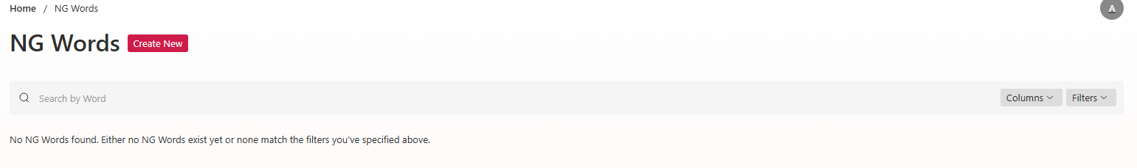
Figure 3: Default list view generated by Payload CMS for the NGWords collection
Access control was added to ensure that the NG Words list could be managed safely. All authenticated CMS users were allowed to read the NG Words list. This allowed editors or other CMS users to refer to the restricted word list when needed. However, modification operations were restricted. Updating and deleting NG Words records were only allowed for users with administrative permission.
The permission logic was implemented through the project’s role-based access control system. A user could manage NG Words if the user was a root administrator, had full permission, or had the specific NGWords:manage permission. In practice, this permission was configured so that only administrative users could modify the list, while other CMS users could only view it. This design prevented unauthorized users from changing the validation source used by the article checking process.
In the collection configuration, the default create operation was disabled. This decision was related to the requirement that NG Words should be added mainly through the CSV import function instead of being manually created one by one through the default CMS form. This helped keep list management more controlled and suitable for bulk operations.
To support CSV import and export, a custom toolbar component was added to the NG Words list page. This toolbar was inserted into the collection list view by using Payload’s admin component customization mechanism. The toolbar appeared before the list table and provided the actions needed to import a CSV file, export the current NG Words list, and choose the import mode.
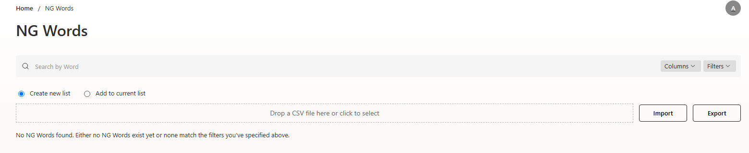
Figure 4: NGWords list view with the custom import/export toolbar
The toolbar also applied permission checking on the client side. If the current user did not have permission to manage NG Words, the toolbar was hidden from the interface. However, this UI-level restriction was not the only protection. The import and export API routes also checked the user’s authentication and management permission before performing any operation. Therefore, the feature used both UI-level control and server-side permission validation.
This design allowed the system to reuse Payload’s generated collection interface while extending it with project-specific actions. The standard list interface was used for viewing and managing records, while the custom toolbar provided bulk import and export functionality required by the business requirement.

CSV Import and Export Logic
Since the NG Words list may contain many entries, managing the list manually through individual operations would be inefficient. Therefore, the system supports bulk import and full-list export through CSV files. The CSV format is intentionally simple: each line contains one NG word, and no header row is required.
The import function supports two modes: Create new list and Insert to current list. Although these two modes differ in how they update the stored NG Words list, they share several common processing steps. In both cases, the client first validates that the selected file is a CSV file before submitting it. After the file is sent to the server, the system authenticates the user, checks the NGWords:manage permission, validates the uploaded file, reads the CSV content, splits it line by line, normalizes each word, and ignores blank lines. The normalization step helps ensure consistent storage and comparison by applying text normalization, converting words to lowercase, and trimming surrounding spaces.
After parsing the file, the system checks whether duplicate words exist inside the uploaded CSV file. If duplicates are detected, the import process is rejected before any database update is performed. The user is then asked to correct the file before importing it again. In addition, the user can download an annotated CSV file that shows the duplicated words and their corresponding line numbers.
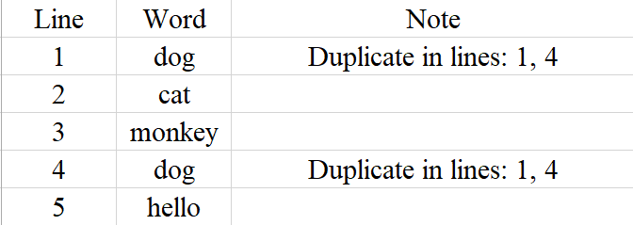
Figure 5: Example of annotated CSV file returned
The difference between the two import modes begins after the duplicate check. In Create new list mode, the uploaded CSV file is used to replace the entire current NG Words list. Because this action removes the previous list, the client shows a confirmation modal before the request is actually submitted. After confirmation, the server deletes all existing NG Words records and then sequentially inserts the normalized words from the uploaded file. According to the business requirement, this mode does not roll back the whole operation if some words fail during insertion. Instead, successfully imported words are kept, while failed ones are recorded and returned in the response.
In Insert to current list mode, the existing NG Words list is preserved. After the CSV content has been parsed and validated, the system loads the current NG Words records from the database and compares them with the uploaded words. Words that already exist in the current list are skipped and recorded as failed items. Only non-existing words are inserted. This mode therefore extends the current list instead of replacing it.

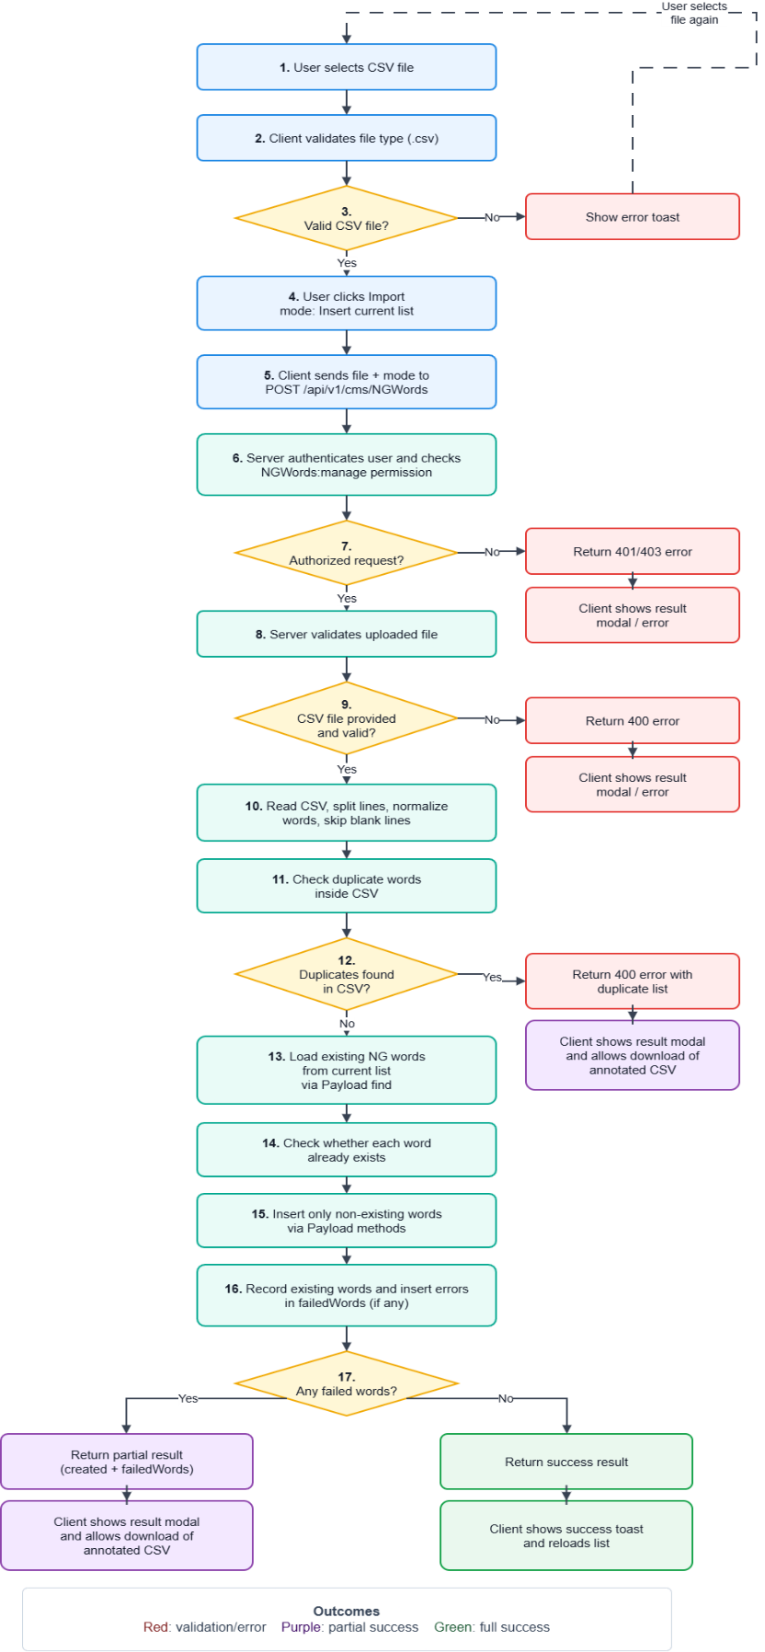  (a): Insert to current list mode | 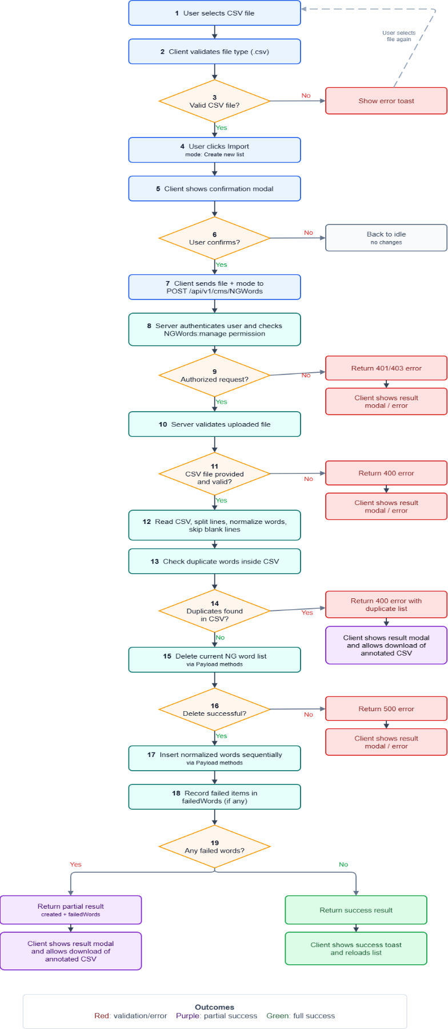  (b): Create new list mode
Figure 6: CSV import workflows for NG words management
Figure 6 illustrates the CSV import workflows of the NG Words feature. Figure 6(a) presents the Insert to current list mode, while Figure 6(b) presents the Create new list mode.
The export function allows authorized users to download the entire NG Words list as a CSV file. The system retrieves all NG Words records through Payload and returns a CSV file in which each line contains one word. Since the business requirement only needs full-list export, the export process does not depend on the current search or filter state of the CMS list view.
If the import succeeds completely, the system returns a success response and the client shows a success message before reloading the list. If some words cannot be imported, the system returns a partial result including the number of created items and the failed words. In this case, the client shows a result modal and allows the user to download an annotated CSV file. The annotated file contains the original lines together with error notes, making it easier for the user to identify and correct problematic entries (the annotated CSV file is similar with figure 5).

NG Words Checking Logic and UI Feedback
The NG Words checking feature was implemented as a reusable helper function used during the article review workflow. In the submit-for-review process, this helper is called after the article passes general validation and before the article workflow status is changed to ready for review. Therefore, the main responsibility of this function is to detect restricted words in the current article content and return structured data that can be displayed in the CMS interface.
The checking process consists of four main steps. First, the article content is extracted into plain text segments. Second, the NG Words list is loaded from the database through Payload CMS. Third, each NG word is compared with the extracted article text. Finally, if matches are found, the system builds preview data with highlighted text so that the CMS user can easily locate the problematic content.
The fields checked by this function are title, description, and content. The title and description fields are plain text fields. Their values are split by line breaks, cleaned by removing unnecessary spaces, and converted into text segments. Empty segments are ignored.
The content field requires a more complex extraction process because it is stored as rich text data. The helper traverses the Lexical editor structure and extracts readable text from different node types. For normal rich text nodes, paragraph, heading, and quote nodes are treated as text blocks. For list nodes, each list item is extracted as a separate segment, with a prefix representing the list type, such as bullet, numbered, or checklist item. For table nodes, each row is converted into a segment by joining the extracted text from its cells.
The extraction logic also supports custom blocks used in the project. For a Caption Box block, the system extracts both the label and the nested content. For a CTA block, the button text is extracted and checked. For a Link Card block, only external link information is checked, including the external title and external description. For a Message Bubble node, the system extracts the speaker name and the message content. This makes the validation more complete because NG words may appear not only in normal paragraphs, but also inside structured rich text components.
The main checking logic can be summarized by the following pseudo-code:
Input:
articleData
NGWords collection
Output:
matchesByField
1. Extract article text:
titleSegments ← extract plain text from article title
descriptionSegments ← extract plain text from article description
contentSegments ← extract text from rich text content and custom blocks
2. Group extracted text by field:
fieldSources ← [
{ field: "title", segments: titleSegments },
{ field: "description", segments: descriptionSegments },
{ field: "content", segments: contentSegments } ]
3. Initialize result:
matchesByField ← empty object
4. Load NG Words from database by pages:
page ← 1
limit ← 1000
while true:
ngWordsPage ← payload.find(
collection = "NGWords",
page = page,
limit = limit
)
for each ngWord in ngWordsPage:
dbWord ← trim(ngWord.word)
if dbWord is empty:
continue
for each source in fieldSources:
matched ← false
for each segment in source.segments:
if matchExists(segment, dbWord):
matched ← true
break
if matched:
if matchesByField[source.field] does not exist:
create matchesByField[source.field]
if dbWord is not already in matchesByField[source.field].words:
add dbWord to matchesByField[source.field].words
if page >= ngWordsPage.totalPages:
break
page ← page + 1
5. For each field that contains matched words:
sort matched words by their first appearance in the article
build preview blocks with highlighted matched text
6. Return matchesByField

In this implementation, the database is used as the source of the NG Words list. The helper does not send a database query for each article segment. Instead, it retrieves NG Words records from the NGWords collection using payload.find. The records are loaded with pagination, using a limit of 1000 records per page. If the collection contains more than 1000 records, the helper continues loading the next page until all NG Words have been processed.
After a page of NG Words is loaded, the helper iterates through each NG word. For each word, it checks whether that word appears in any segment of each article field. This means that each NG word is compared against the extracted text segments of title, description, and content. If a word is found in at least one segment of a field, the word is added to the result group of that field.
The matching itself is performed in the application logic, not directly in SQL. This approach keeps the implementation flexible because the article content is not stored as a single simple text column. Instead, the content may contain nested rich text nodes, tables, and custom blocks. By extracting the article into text segments first and then performing the comparison in the helper function, the system can apply the same checking rule to different content structures.
Before comparison, both the article text and the NG word are normalized. The normalization process applies Unicode NFKC normalization, converts text to lowercase, and removes unnecessary spaces. This reduces the risk of missing a match because of differences in character width, letter case, or surrounding spaces.
The matching rule depends on the type of NG word. For Latin-based words, the system uses word-boundary matching with a regular expression. This avoids matching a word when it only appears as part of a longer unrelated word. For example, a short Latin NG word should not be detected inside another longer word if it is not a separate word. For non-Latin words, the system uses substring matching because word boundary rules are not always suitable for languages such as Japanese.
When matched words are found, the helper does not only return the word list. It also builds preview data for the UI. The result is grouped by article field in an object called matchesByField. Each field group contains two main parts: words, which stores the matched NG words, and blocks, which stores preview blocks used for display.
For normal text, the preview block is represented as a paragraph. Each paragraph preview contains smaller parts, and each part has a highlight value. If highlight is true, the UI displays that text as a matched NG word. If it is false, the UI displays it as normal surrounding context. To keep the preview readable, the helper does not always return the full original text. Instead, it shows the matched word with a limited number of surrounding characters and adds ellipses when the original text is longer.
For table content, the preview data is represented differently. The helper identifies rows that contain matched NG words and returns the row index together with highlighted cell content. This allows the CMS interface to show which table row contains the restricted word and highlight the matched cell text.
For custom blocks, the preview includes additional labels so that the user can understand where the match appears. For example, if an NG word appears in a CTA block, the preview indicates that the match belongs to the CTA button text. If it appears in a Link Card, Caption Box, or Message Bubble, the preview includes the corresponding block label and field label. This makes the result easier to understand than returning only plain text.
If the helper returns a non-empty matchesByField object, the submit-for-review API returns an error response with the code ng_words_found. In this case, the article is not submitted for review and the workflow status remains unchanged. On the frontend, the returned matchesByField data is stored in the NG Words review provider and displayed in the NG Words review box in the CMS sidebar. The UI shows the affected fields, the matched NG words, and the highlighted preview content so that the author can identify and correct the problem.
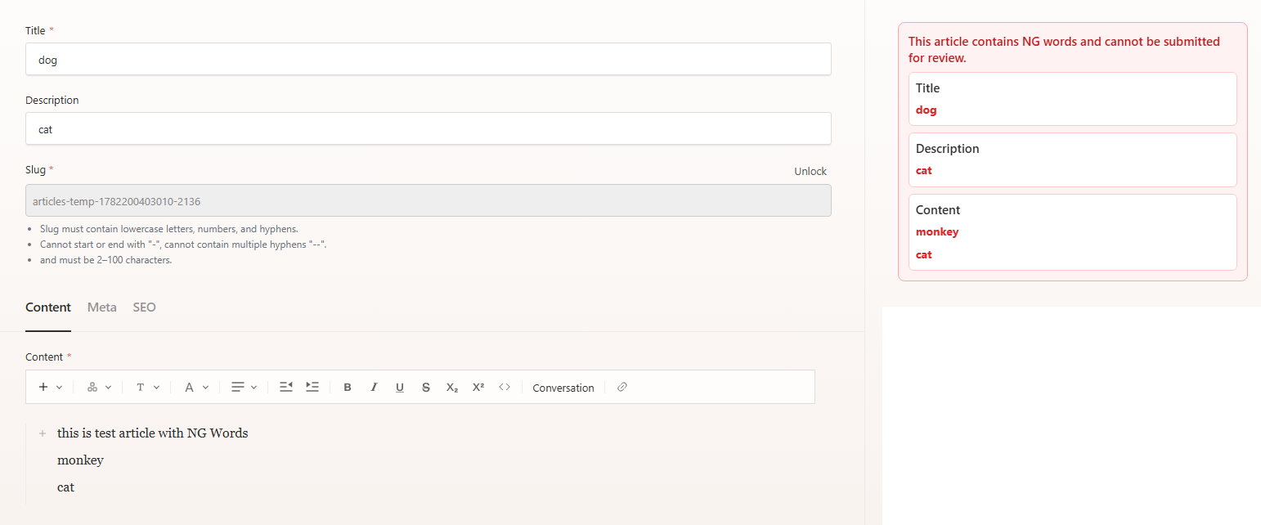
Figure 7: Example of NG Words review box
If no NG words are found, the helper returns an empty result. The submit-for-review process can then continue normally, and the article workflow status can be updated to ready for review.

Result and Discussion
The NG Words feature was successfully implemented as part of the CMS content management and article review workflow. The feature provides two main capabilities: managing the NG Words list in the CMS and automatically checking article content before it is submitted for review.
For the management part, a new NGWords collection was added to Payload CMS. This collection stores restricted words in the database and allows authorized users to manage the list. The CMS interface supports viewing, updating, deleting, importing, and exporting NG Words. The import function supports two modes: creating a new list and inserting words into the current list. This provides flexibility for administrators when maintaining the restricted word list. The export function allows the full list to be downloaded as a CSV file, which is useful for backup, review, or external editing.
The access control design also worked as expected. General authenticated CMS users can view the NG Words list, while management actions such as updating, deleting, importing, and exporting are restricted to users with the required permission. This prevents unauthorized users from modifying the validation source used in the review workflow.
For the article review workflow, the NG Words checking logic was integrated before an article can be submitted for review. When an author clicks the Submit for Review button, the system first validates the article data and then checks the content against the NG Words list. If restricted words are detected, the submission is blocked and the article remains in its current workflow status. If no restricted words are found, the article can continue to the ready-for-review stage.
The checking function supports multiple content structures. It checks plain text fields such as title and description, as well as rich text content stored in the article body. It can extract and check text from paragraphs, headings, quotes, lists, tables, and several custom blocks such as CTA, Link Card, Caption Box, and Message Bubble. This makes the validation more complete because restricted words may appear in different parts of an article, not only in normal paragraphs.
Another important result is the UI feedback provided to CMS users. When NG words are found, the system returns structured data grouped by article field. The CMS interface displays the affected fields, the matched NG words, and preview content with highlighted text. This helps authors quickly identify where the problematic words are located and correct the article before submitting it again.
Although the feature works correctly for the current requirement, there are still some limitations. First, the current matching logic loads NG Words from the database and compares each word with the extracted article text segments in application logic. This approach is simple and suitable for the expected scale of the system because the checking process runs only when an article is submitted for review. However, the processing cost increases when the article is very long or when the NG Words list becomes very large.
Second, the checking logic needs to be maintained when new rich text blocks are added to the article editor. If a new custom block contains user-visible text, the extraction function must be updated so that NG Words can also be checked inside that block. Otherwise, restricted words inside newly introduced structures may be missed.
Third, the matching rules may still have limitations depending on language and content format. The implementation uses whole-word matching for Latin-based words and substring matching for non-Latin words. This design reduces some false positives for English-like text and supports Japanese-like text better, but it may not cover all language-specific edge cases perfectly.
For future improvement, the matching process could be optimized by normalizing article text segments only once before comparison. If the NG Words list grows significantly, a more efficient multi-pattern matching algorithm such as Aho-Corasick [12] could also be considered. This would allow multiple NG words to be detected in a single scan of the article text.

C Point Feature

Requirement and Scope
In this project, C Point refers to a point balance associated with an end-user account. It is a type of user reward or loyalty point that can be displayed to the user as part of their account information. Unlike basic profile fields such as name or birth date, the C Point value is not stored directly in the normal profile response. Instead, it must be retrieved from a third-party point balance service.
The C Point feature was implemented to extend the user information displayed on the Frontweb /my-page screen. Before this feature was added, the page already displayed basic end-user profile information such as nickname, name, birth date, gender, newsletter subscription status, and selected interest categories. However, the response did not include the user’s C Point information.
Figure 8 shows an example of the profile API response before the C Point field was added.
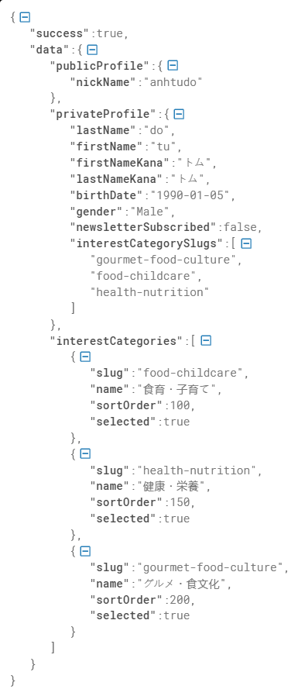
Figure 8: Example of profile API response before added C Point
The requirement of this task was to add C Point information to the existing profile response so that the Frontweb could display it together with the current user profile data. The task did not require building a new page or changing the main profile flow. Instead, the main scope was to update the API response by adding a new cPoint object and then make the Frontweb use this value for display.
The scope of my work included understanding the existing /my-page profile data flow, identifying where the profile response was created, retrieving the C Point value, adding it to the response, and verifying that the Frontweb could receive and display the new information correctly.

Data Flow and Implementation Logic
When the /my-page screen requests user profile data, the Frontweb internal API route first checks the Authorization header. If the header is missing, the request is rejected with an unauthorized response. If the header exists, the route forwards the request to the CMS API endpoint for the authenticated user profile. The authorization header is kept in the forwarded request so that the CMS API can identify the current user.
On the CMS side, the API extracts the bearer token from the request and verifies it using Firebase authentication. After the token is verified, the system obtains the user identifier and uses it to read the existing user profile data. This profile data includes information such as public profile, private profile, and selected interest categories.
The special point of this feature is that the C Point value is not stored directly in the same profile data source. Instead, it must be retrieved from a third-party point balance API. Therefore, after verifying the user, the CMS API uses the Firebase ID token to call the external point balance service. This service returns the user’s current point balance and, when available, the expiration time of the point balance.
The returned point data is then converted into a simple structure used by the Frontweb:
{
"cPoint": {
"point": 0,
"expireAt": null
}
}

The point field represents the current C Point balance of the user. The expireAt field represents the expiration time of the point balance if this information is provided by the third-party service. If the external service is not configured, returns an error, or cannot be reached, the system returns a default value with point equal to 0 and expireAt equal to null. This fallback prevents the whole profile page from failing when the point balance service is temporarily unavailable.
The CMS API retrieves the profile data, active interest categories, and C Point balance, then combines them into one response. The updated response structure can be summarized as follows:
{
"success": true,
"data": {
"...profile": "...",
"interestCategories": [],
"cPoint": {
"point": 0,
"expireAt": null
}
}
}

With this update, the Frontweb can continue using the same profile response for the /my-page screen. The only difference is that the response now includes the additional cPoint object. Therefore, the Frontweb does not need to call a separate endpoint only for C Point information.
This implementation kept the existing architecture mostly unchanged. The Frontweb still communicates with its internal API route, and the CMS API still prepares the profile response. The main additional logic is the integration with the third-party point balance API, which allows the system to enrich the existing profile response with C Point information.

Result and Discusstion
After implementation, the /my-page screen was able to receive and display the user’s C Point information together with the existing profile data. The profile response was extended with a new cPoint object, so the Frontweb did not need to call a separate API only for point information.
The main change was made on the CMS API side. After verifying the user’s Firebase token and reading the existing profile data, the API called a third-party point balance service to retrieve the current C Point value. The returned data was then added to the final profile response.
This approach kept the existing data flow mostly unchanged. The Frontweb still called the same internal profile API route, and the CMS API still returned the complete profile response. The only difference was that the response now included additional C Point data.
A fallback was also added for the third-party API. If the point balance service was not configured, failed, or returned an error, the system returned a default value with point equal to 0 and expireAt equal to null. This prevented the whole profile page from failing because of an external service issue.
The limitation of this feature is that the C Point value depends on a third-party point balance service. Because the CMS API needs to call this external service before returning the profile response, the /my-page screen may take slightly longer to load when the service response is slow.

Home Banners Feature

Requirement and Scope
The Home Banners feature was implemented to display promotional banner content on the Frontweb homepage. In this task, the CMS side had already provided the API and returned the required banner configuration data. Therefore, the main scope of the implementation was on the Frontweb side.
The requirement was to receive banner data from the existing API, process the response safely, and render the correct banner layout according to the design. The homepage already contained several content sections such as first view articles, pickup articles, new articles, stories, videos, and campaign articles. The Home Banners feature added a new visual banner area at the top of the homepage.
The feature supported two main banner layouts: top hero banners and top side banners. The top hero layout was used for large promotional banners, while the top side layout was used for a different banner arrangement. The Frontweb needed to decide which layout should be displayed based on the enabled status of the returned banner data.
The scope of my work included integrating the banner settings API into the homepage data loading flow, checking the enabled status of the returned banners, selecting the correct banner component, and ensuring that the homepage rendered the banner area correctly without breaking the existing sections.

Data Fetching and Rendering Logic
The Home Banners feature used an existing CMS API endpoint to retrieve banner settings for the homepage. The CMS side was responsible for reading the banner configuration and returning the data in a format that could be used by the Frontweb. Therefore, my work focused on consuming this response, checking the banner status, and rendering the correct UI layout.
The API response contained two main banner settings: topHeroBanners and topSideBanners. Although these values were returned as arrays in the response, the CMS configuration allowed only one Top Hero banner and one Top Side banner to be added for the homepage. Therefore, the Frontweb only needed to determine which configured banner type was enabled and render the corresponding layout.
Figure 9 shows an example of the homepage banner settings API response.
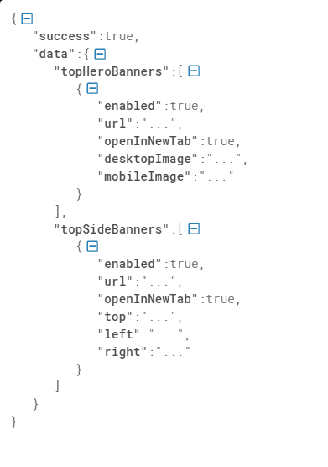
Figure 9: Simplified homepage banner settings API response
As shown in Figure 9, the response includes both topHeroBanners and topSideBanners. Each banner setting contains an enabled field, which is used by the Frontweb to decide whether the banner can be displayed. The response also includes image information such as image URL, alternative text, width, and height. This data is used to render the banner image and link behavior correctly.
On the Frontweb side, the banner data was retrieved using the getHomeBannerSettings function. This function called the homepage banner settings API and returned the two banner settings to the homepage component.
If the API request failed, returned an invalid response, or returned success: false, the function returned empty arrays for both topHeroBanners and topSideBanners. This fallback made the feature safer because the homepage could still render normally even when banner data was unavailable.
The HomePage component loaded the banner data together with other homepage data, such as first view articles, pickup articles, new articles, stories, and campaigns. This allowed the banner section to become part of the existing homepage rendering flow.
After the banner data was loaded, the homepage checked which banner type should be displayed. The rendering logic prioritized the Top Hero banner. If the Top Hero banner was enabled, the homepage rendered the TopHero component. If the Top Hero banner was not enabled but the Top Side banner was enabled, the homepage rendered the TopSide component instead. If neither banner type was enabled, no banner component was displayed.
The simplified rendering logic can be described as follows:
Load homepage banner settings
if Top Hero banner is enabled:
render TopHero
else if Top Side banner is enabled:
render TopSide
else: render no homepage banner
This logic ensured that only one banner layout was displayed at the top of the homepage. The hero banner layout had higher priority than the side banner layout. Therefore, if both banner settings were enabled, the homepage displayed the Top Hero layout.
The selected banner component was rendered before the first view article section. This placement allowed promotional banner content to appear at the top of the homepage while keeping the rest of the homepage sections unchanged.
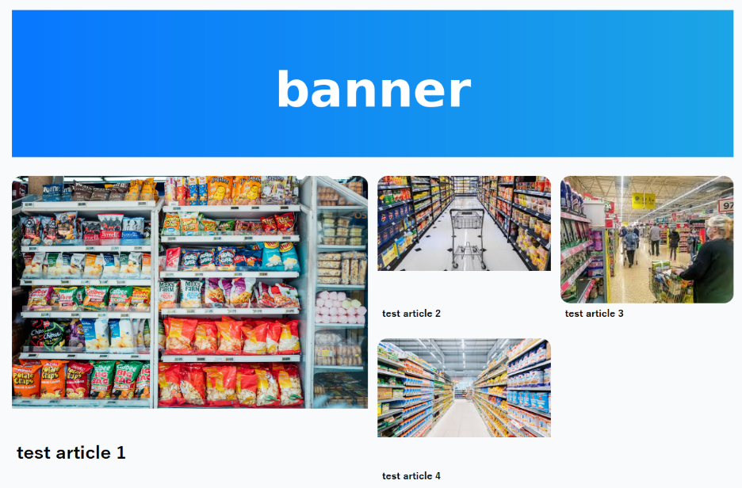  (a): Top Hero banner layout | 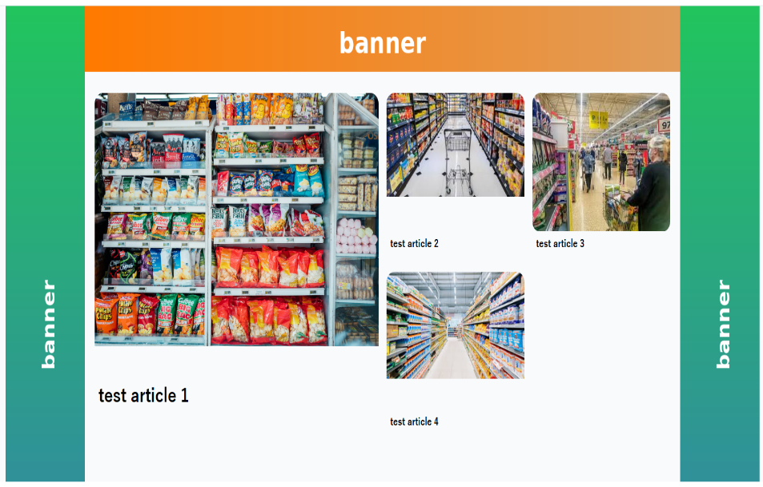  (b): Top Side banner layout
Figure 10: Homepage banner rendering examples

Other contributions
In addition to the main features presented in the previous sections, I also contributed to several smaller tasks during the internship. Although these tasks were not large enough to be presented as separate use cases, they helped improve the usability, stability, and maintainability of the system.
One of my contributions was related to rich text editor improvements in the CMS. I worked on adjusting and extending rich text behavior so that content editors could manage article content more flexibly. For example, I supported text color customization in rich text content, allowing editors to apply visual formatting more easily according to content requirements. This task required me to understand how rich text data was configured in the CMS and how it was rendered or processed in related parts of the system.
I also contributed to frontend adjustment tasks on the Frontweb application. Some tasks involved modifying the user interface to match customer requirements, such as removing unnecessary visual elements and adjusting the display of components. These tasks helped me become more familiar with the relationship between design requirements, frontend components, and rendered output on the public-facing website.
Another contribution was related to data rendering between the backend and the Frontweb. For some frontend components, the data returned from the CMS or backend needed to be processed before it could be displayed correctly. I worked on handling and transforming received data so that the frontend could render the required content in the expected layout. This helped me better understand the data flow from CMS configuration to frontend presentation.

CONCLUSION AND PERSPECTIVE

Conclusion
During my internship at FPT Software, I had the opportunity to participate in the development of a real product promotion website used in a professional software development environment. Through this internship, I was able to apply the knowledge I had learned at university to practical tasks and gain a better understanding of how a large web application is designed, implemented, tested, and maintained.
My main work focused on developing and improving features across the CMS, backend, and Frontweb. The selected features presented in this report include the NG Words feature, the C Point feature, and the Home Banners feature. These tasks allowed me to work with different parts of the system, from CMS collection configuration and backend validation logic to API integration and frontend rendering.
The NG Words feature was the most complete feature I worked on during the internship. It involved creating a new Payload collection, managing restricted words through the CMS, implementing CSV import and export, checking article content before submission, and displaying matched words to CMS users. Through this feature, I learned how to design a feature that combines data modeling, access control, server-side processing, and user interface feedback.
In addition, the C Point feature helped me understand how an existing profile API could be extended by integrating data from an external service. The Home Banners feature gave me more experience with Frontweb development, especially in consuming CMS-provided data and rendering UI components based on configuration and design requirements.
Besides these main features, I also contributed to smaller development tasks such as rich text editor improvements, UI adjustments, validation updates, data rendering fixes, debugging, and code review revisions. These tasks helped me become more familiar with the project structure and the development workflow used by the team.
The internship improved both my technical skills and my understanding of professional software development. I gained practical experience with technologies such as Payload CMS, Next.js, React, TypeScript, PostgreSQL, Firebase, Git, and CI/CD workflows. More importantly, I learned how to read existing code, follow team conventions, communicate with other developers, respond to code review feedback, and deliver features in an organized development process.

Future Perspective
In the future, several improvements could be made to enhance the system. For the NG Words feature, the checking process could be optimized by normalizing article text segments only once before comparison. If the NG Words list becomes very large, a more efficient multi-pattern matching algorithm could also be considered to detect multiple restricted words in a single scan. In addition, NG Words management could be extended with categories, severity levels, or more detailed review reports.
For CMS and frontend features, future improvements could focus on making content configuration more flexible and easier for editors to use. The Home Banners and other promotional content features could be extended with more display conditions, scheduling options, and better preview support. This would help content managers control promotional content more efficiently.
From a development perspective, future work could also improve testing and maintainability. More reusable validation helpers, clearer component structures, and additional test cases could make the system easier to extend and reduce the risk of regressions when new requirements are added.
Through this internship, I gained valuable experience in full-stack web development and learned how software is developed in a real company project. The experience helped me better understand the connection between academic knowledge and practical implementation. It also gave me a stronger foundation for future work in web development, backend development, and software engineering.

REFERENCES

[1] Payload CMS, Payload CMS Documentation. https://payloadcms.com/docs, n.d.
[2] PostgreSQL Global Development Group, PostgreSQL Documentation. https://www.postgresql.org/docs/, n.d.
[3] Vercel, Next.js Documentation. https://nextjs.org/docs, n.d.
[4] Meta, React Documentation. https://react.dev/reference/react, n.d.
[5] Tailwind Labs, Tailwind CSS Documentation. https://tailwindcss.com/docs, n.d.
[6] Google, Firebase Documentation. https://firebase.google.com/docs, n.d.
[7] Git, Git Documentation. https://git-scm.com/doc, n.d.
[8] GitHub, GitHub Docs. https://docs.github.com, n.d.
[9] Google Cloud, Cloud Run Documentation. https://cloud.google.com/run/docs, n.d.
[10] Google Cloud, Cloud SQL Documentation. https://cloud.google.com/sql/docs, n.d.
[11] Google Cloud, Cloud Storage Documentation. https://cloud.google.com/storage/docs, n.d.
[12] A. V. Aho and M. J. Corasick, “Efficient string matching: An aid to bibliographic search,” Communications of the ACM, 1975, vol. 18, no. 6, pp. 333–340. https://dl.acm.org/doi/10.1145/360825.360855

APPENDICES

APPENDIX A: Develop and Release Workflow
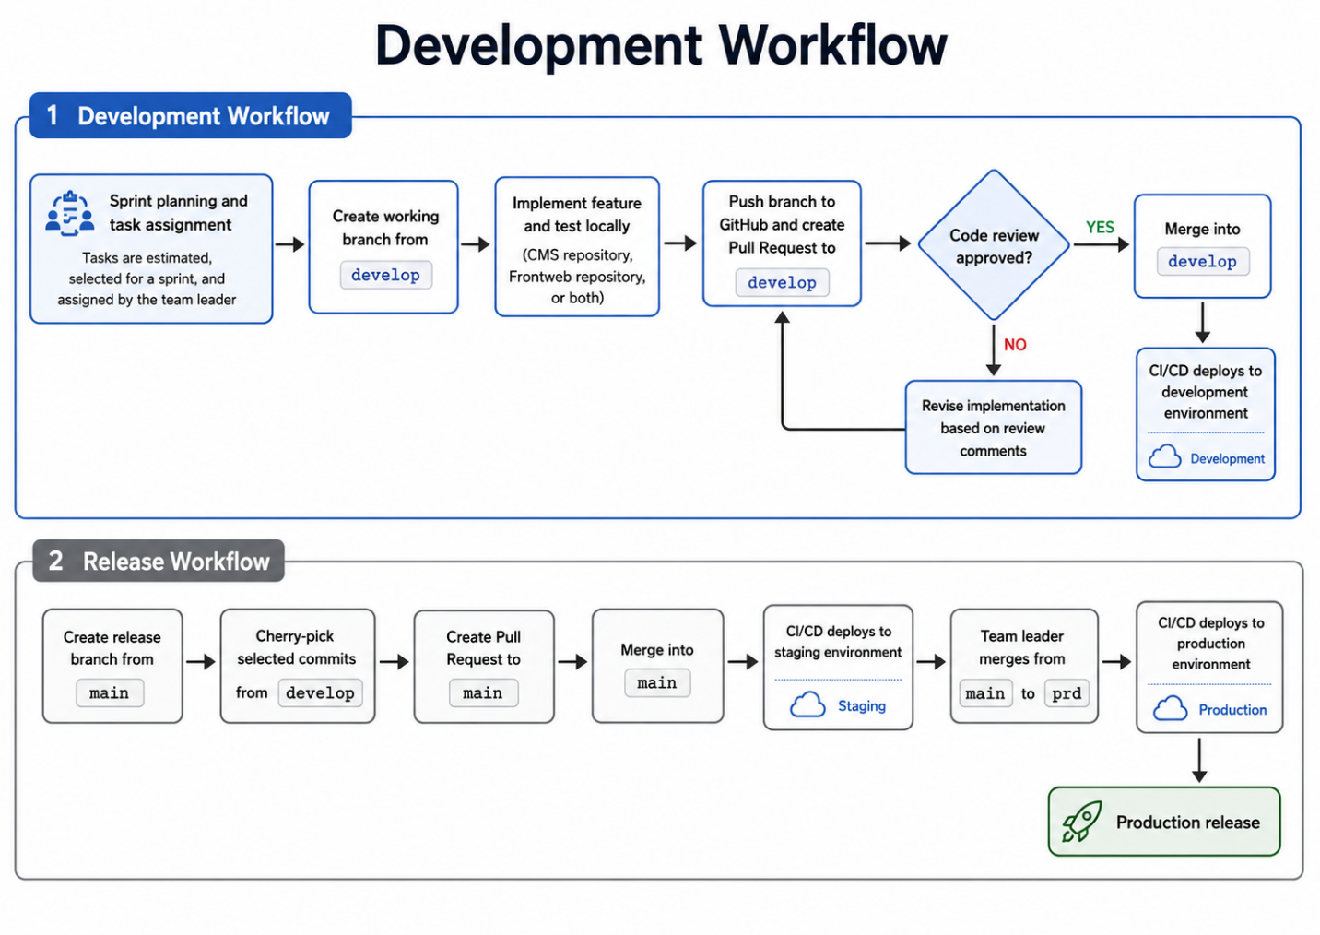

APPENDIX B: Generated Migration File for the NGWords Collection

import { MigrateUpArgs, MigrateDownArgs, sql } from '@payloadcms/db-postgres'
export async function up({ db, payload, req }: MigrateUpArgs): Promise<void> {
await db.execute(sql`
CREATE TABLE "n_g_words" (
"id" serial PRIMARY KEY NOT NULL,
"word" varchar NOT NULL,
"updated_at" timestamp(3) with time zone DEFAULT now() NOT NULL,
"created_at" timestamp(3) with time zone DEFAULT now() NOT NULL
);
ALTER TABLE "payload_locked_documents_rels" ADD COLUMN "n_g_words_id" integer;
CREATE UNIQUE INDEX "n_g_words_word_idx" ON "n_g_words" USING btree ("word");
CREATE INDEX "n_g_words_updated_at_idx" ON "n_g_words" USING btree ("updated_at");
CREATE INDEX "n_g_words_created_at_idx" ON "n_g_words" USING btree ("created_at");
ALTER TABLE "payload_locked_documents_rels" ADD CONSTRAINT "payload_locked_documents_rels_n_g_words_fk" FOREIGN KEY ("n_g_words_id") REFERENCES "public"."n_g_words"("id") ON DELETE cascade ON UPDATE no action;
CREATE INDEX "payload_locked_documents_rels_n_g_words_id_idx" ON "payload_locked_documents_rels" USING btree ("n_g_words_id");`)
}
export async function down({ db, payload, req }: MigrateDownArgs): Promise<void> {
await db.execute(sql`
ALTER TABLE "n_g_words" DISABLE ROW LEVEL SECURITY;
DROP TABLE "n_g_words" CASCADE;
ALTER TABLE "payload_locked_documents_rels" DROP CONSTRAINT "payload_locked_documents_rels_n_g_words_fk";
DROP INDEX "payload_locked_documents_rels_n_g_words_id_idx";
ALTER TABLE "payload_locked_documents_rels" DROP COLUMN "n_g_words_id";`)
}

APPENDIX C: Example of Payload Operations for Data Manipulation
In the NG Words feature, database operations were performed through Payload CMS operations instead of manually written SQL queries. The following simplified example shows how the system used Payload methods to read, create, and delete NG Words records.
// Find existing NG Words
const existingWords = await payload.find({
collection: 'NGWords',
where: {
word: {
in: importWords,
},
},
limit: importWords.length,
depth: 0,
});
// Create a new NG Word record
await payload.create({
collection: 'NGWords',
data: {
word: item.word,
},
});
// Delete an NG Word record
await payload.delete({
collection: 'NGWords',
id: doc.id,
});

APPENDIX D: Data Flow Diagram of the C Point Feature
